In this lab we will learn how to limit the scope of the variable to container and how to perform looping

Step 1: Prepare Database

We will use the same database created in above lab. Make sure to empty Customer Table so that there will not be any confusion.

Step 2: Crate new Integration Services Project

Create new SSIS project using SQL Server Data tools.

Step 3: Add Connection Managers

Add Ado.net Connection manager and connect it to ContainerDemo database

Step 4: Add Container

Add “For Loop container” in control flow.

Step 5: Create variable

In order to loop, first thing we need is variable. Create a variable at package level called Counter.

Step 6: Add sequence container

Add one more sequence container in the same control flow.

Step 7: Check current variable scope.

Make sure variable window is open.

* Click the sequence container. You will find Counter variable in the variable window.
* Click for loop container. Counter variable is still available

### **https://www.codeproject.com/KB/database/789618/25.png**

### Step 8: Change variable scope

1. Select the variable in variable window, click the Move Variable button.

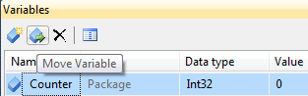

1. A new window called “Select new scope” will popup. Select the for loop container which was added in one of the previous step.

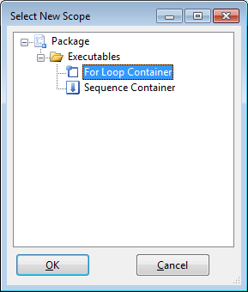

Step 9: Recheck variable scope.

Perform the step 7 again.

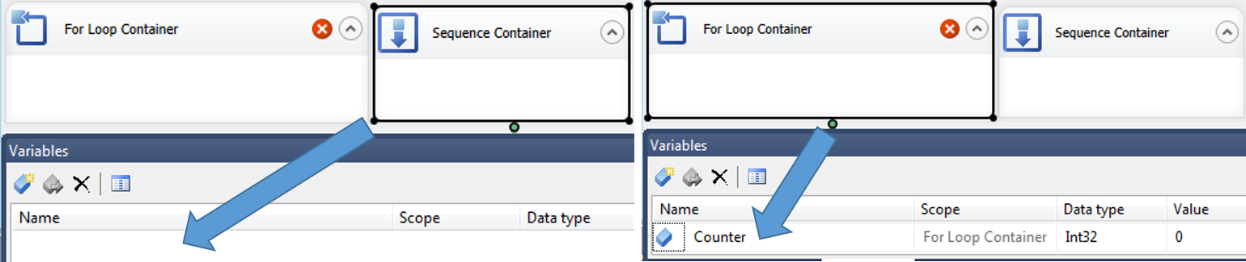

Step 9: Remove the sequence container

Select sequence container and press delete key. Purpose of that container in this demo was only testing

Step 10: Configure For Loop container.

1. Double click the “For loop container”. It will open up the “For loop editor” window.
2. Set the values to the properties as show in the figure.

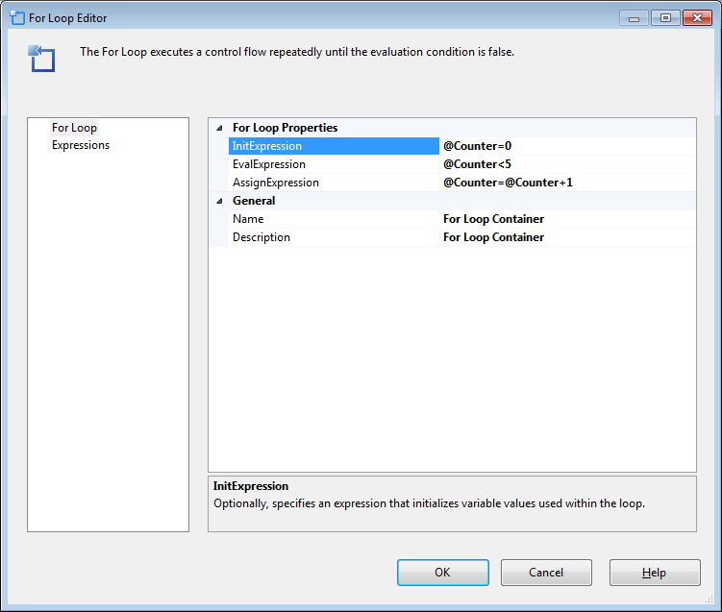

**Note:** It’s self-explanatory now. For loop will execute five times

### Step 11: Add Execute Sql Task and configure it.

1. Add a new Execute Sql Task inside For loop container.
2. Configure its properties as follows.
   1. ConnectionType to ADO.NET.
   2. Connection to one created in one of the above step.
   3. SQLSourceType to “DirectInput”
   4. Set SQLStatement to “insert into Customer values('A'+cast(@Index as varchar),@Index)”
3. In the “Execute Sql Task editor” window go to “parameter mapping” section and map sql parameter @index to SSIS parameter @Counter

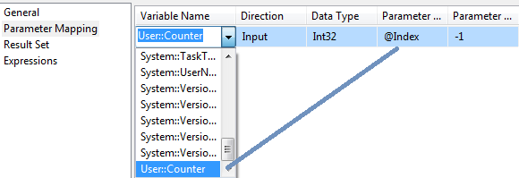

1. Click Ok

### Step 12: Execute and Test

Press F5 for executing package and test the output

